Sang Hwa Lee

INST 346

September 20, 2022

HW-00 : Outfitting a Team with Computers

To this assignment, I will use the PC part picker website that the professor provided during class to organize the necessary computer components. However, this site cannot create a separate link. Therefore, I will attach it as a screenshot of each.

1. **Team Member 1 is the Web Developer for the team. She helps the team to communicate their findings to the end-user by creating dashboards. While she often writes scripts to automate tasks, she doesn't work with the large datasets herself. However, she writes lots of CSS, HTML, and JavaScript. She often has to compare the design document with the site that she is developing, so having a second monitor would really speed up her workflow.**

She needs enough RAM space because she uses a lot of CSS, HTML, and JavaScript. She also needs a graphics card because she checks design documents, and a secondary monitor because she works by comparing sites. However, it does not require significant CPU or graphics processing.

CPU: Intel Core i5 – 12600K 3.7GHz 10-core Processor ($269.99)

CPU cooler : CPU cooler : [Thermalright Assassin X 120 Refined SE 66.17 CFM CPU Cooler](https://pcpartpicker.com/product/q6H7YJ/thermalright-assassin-x-120-refined-se-6617-cfm-cpu-cooler-ax120-se-d3) ($19.89)

Motherboard: Gigabyte B660M DS3H DDR4 Micro ATX LGA 1700 ($109.99)

Memory: Corsair Vengeance LPX 16GB ($53.99)

Storage: Samsung 970 Evo Plus 500GB ($74.50)

Graphics:  MSI GeForce GTX 1650 G5 4 GB VENTUS XS OC Video Card ($179.99)

Case: Fractal Design Focus G ATX Mid Tower Case ($64.98)

Power supply: EVGA W1 600 W 80 ($34.99)

2 Monitor: Acer SB220Q bi 21.5 (each $99.99 Then, total $199.98)

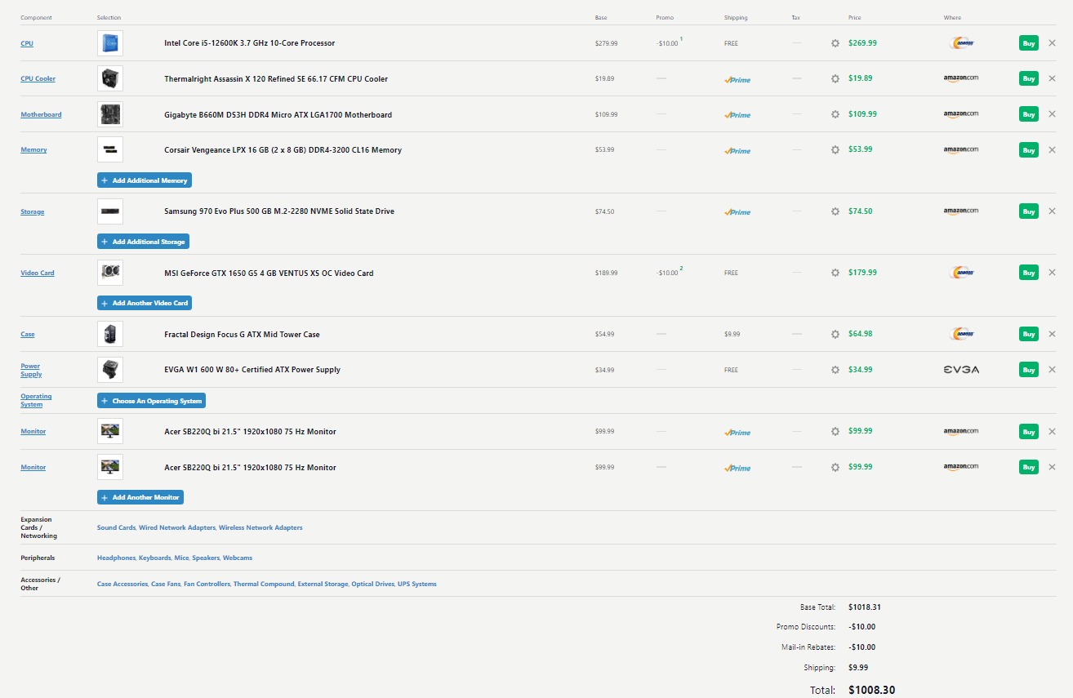**Total Cost: $1008.3**

1. **Team Member 2 is a Data Scientist that focuses on using predictive statistics to build analytical models. She does not use Machine Learning techniques, but frequently has large data sets open on her computer, trying to process them with a variety of tools, like R Studio. These tools use a lot of CPU power and the data sets are quite large, so processing them requires a significant amount of primary memory.**

She needs a significant amount of RAM because she keeps a large data set open while using various tools such as RStudio. Therefore, 32GB of RAM is recommended. Due to the high CPU power consumption, the power supply must be large, and an additional pen must be installed to prevent heat generation. However, I recommend that integrated graphics card because none of her work requires significant graphics processing.

CPU: Intel Core i5 – 12600K 3.7GHz 10-core Processor ($269.99)

CPU cooler : CPU cooler : [Thermalright Assassin X 120 Refined SE 66.17 CFM CPU Cooler](https://pcpartpicker.com/product/q6H7YJ/thermalright-assassin-x-120-refined-se-6617-cfm-cpu-cooler-ax120-se-d3) ($19.89)

Motherboard: Gigabyte B660M DS3H DDR4 Micro ATX LGA 1700 ($109.99)

Memory: Corsair Vengeance LPX 32 GB (2 x 16 GB) DDR4-3600 CL18 Memory ($99.99)

Graphics: Intel Integrated Graphics Card

Storage: Samsung 970 Evo Plus 500GB ($74.50)

Case: Fractal Design Focus G ATX Mid Tower Case ($64.98)

Power supply: Corsair RM (2021) 750 W 80+ Gold Certified Fully Modular ATX Power Supply ($94.99)

Monitor: Acer SB220Q bi 21.5 ($99.99)

**Total Cost: $834.32**

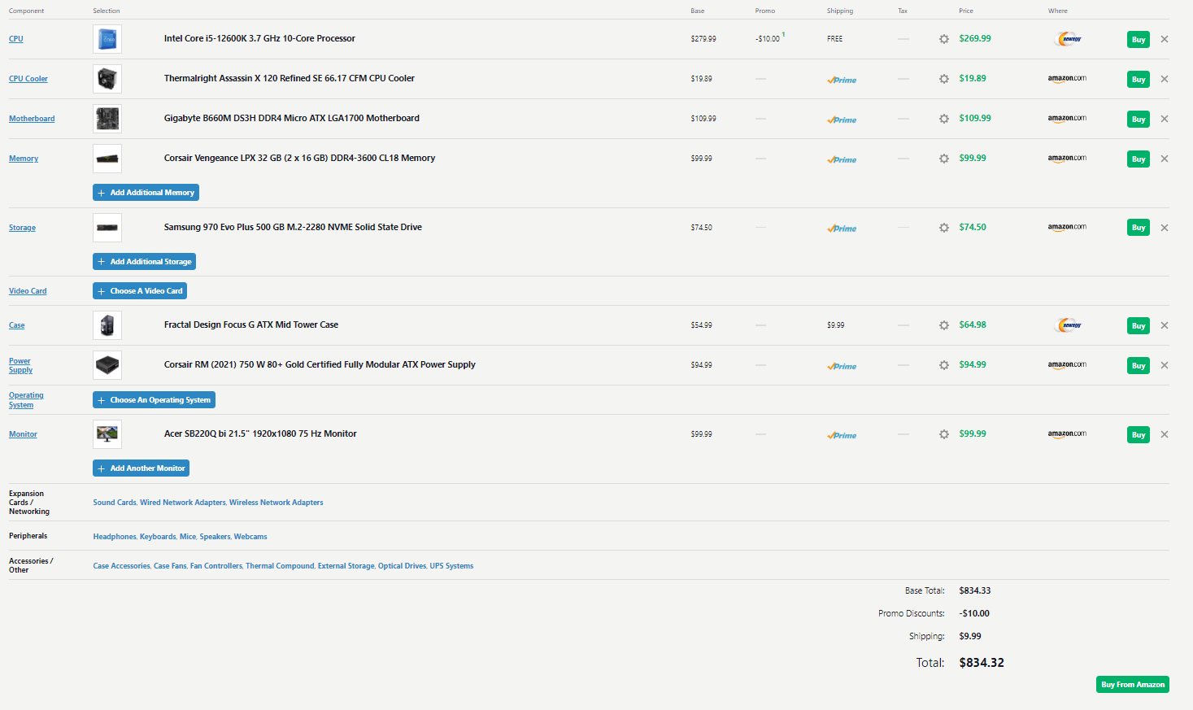

1. **Team Member 3 is a Data Visualization expert. She works with large data sets to model interesting visualizations. Her work is very processor intensive and some of her tools require a dedicated GPU to speed up rendering times.**

Her work requires high-performance machines. In addition to using large data sets, processor-intensive tasks require good CPU and GPU. In addition, 32GB of RAM is recommended because the larger the RAM capacity, the faster the rendering speed.

CPU: Intel Core i7-9700K 3.6 GHz 8-Core Processor ($435.00)

CPU cooler: Thermal right TA140 EX 95.5 CFM CPU Cooler ($ 29.90)

Motherboard: Asus PRIME Z390-P ATX LGA1151 Motherboard (244.00)

Memory: Corsair Vengeance LPX 32 GB (2 x 16 GB) DDR4-3600 CL18 Memory ($99.99)

Graphics: EVGA GeForce RTX 3070 Ti 8 GB FTW3 ULTRA GAMING Video Card ($709.99)

Storage: Samsung 970 Evo Plus 2 TB M.2-2280 NVME Solid State Drive ($189.99)

Case: Fractal Design Focus G ATX Mid Tower Case ($64.98)

Power supply: Corsair RMx (2021) 850 W 80+ Gold Certified Fully Modular ATX Power Supply ($134.99)

Monitor: Acer SB220Q bi 21.5 ($99.99)

**Total Cost: $2008.83**

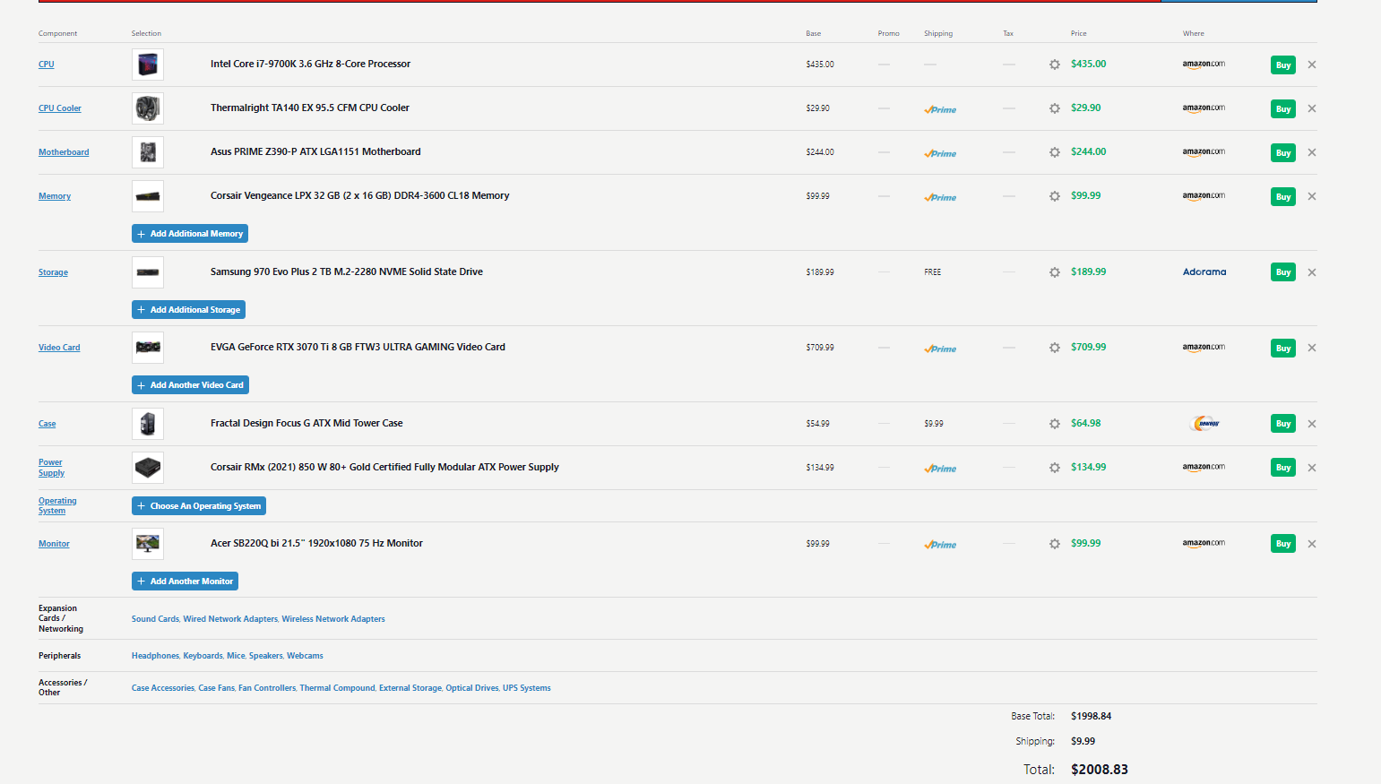

1. **Team Member 4 is a Machine Learning expert. She frequently uses the GPGPU capabilities of her tools in order to speed up processing times. Specifically, she has been working in TensorFlow, which uses the CUDA implementation. Her datasets are also large, but she often works on training samples that are smaller before deploying the models.**

Since her work includes GPGPU function, a graphics card is required. Her dataset is large, but she works on small training samples, so she doesn't need a huge amount of RAM. Therefore, 16GB of RAM is recommended.

CPU: Intel Core i5 – 12600K 3.7GHz 10-core Processor ($269.99)

CPU cooler: Thermal right Assassin X 120 Refined SE 66.17 CFM CPU Cooler ($19.89)

Motherboard: Gigabyte B660M DS3H DDR4 Micro ATX LGA 1700 ($109.99)

Memory: Corsair Vengeance LPX 16GB ($53.99)

Graphics: EVGA GeForce RTX 3070 Ti 8 GB FTW3 ULTRA GAMING Video Card ($709.99)

Storage: Samsung 970 Evo Plus 500GB ($74.50)

Case: Fractal Design Focus G ATX Mid Tower Case ($64.98)

Power supply: EVGA W1 600 W 80 ($34.99)

Monitor: Acer SB220Q bi 21.5 ($99.99)

**Total Cost: $1438.32**

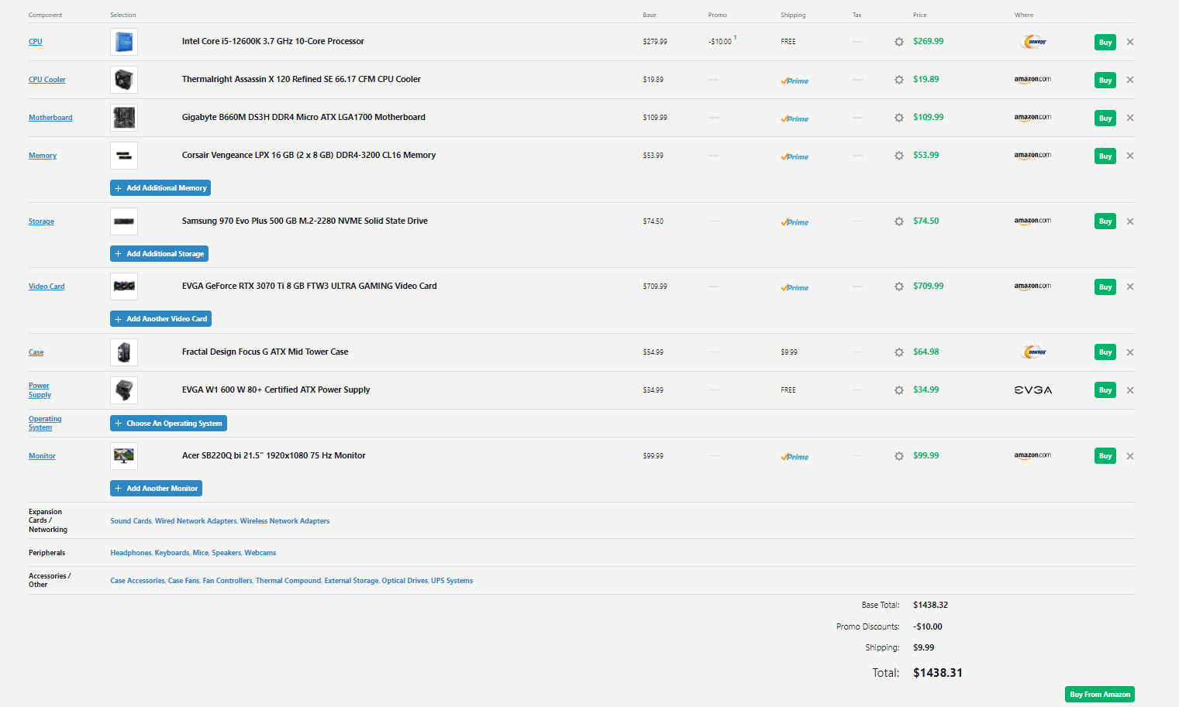

1. **Team Member 5 is the Data Engineer. Her job is to make sure that the data is stored in optimal formats, that the data is properly documented with metadata, and that errors are minimized. The tools she uses aren't very CPU heavy, but they require lots of RAM. She is often working with Open Refine to prepare new datasets for the team and she likes to assign 10 GB of RAM (or more!) to Java while using it to clean datasets.**

Her work does not require significant CPU speed. It also does not require significant graphics specifications. However, more than 10GB of RAM space is required. Therefore, 32GB of RAM is recommended.

CPU: Intel Core i5 – 12600K 3.7GHz 10-core Processor ($269.99)

Motherboard: Gigabyte B660M DS3H DDR4 Micro ATX LGA 1700 ($109.99)

Memory: Corsair Vengeance LPX 32 GB (2 x 16 GB) DDR4-3600 CL18 Memory ($99.99)

Graphics: Intel Integrated Graphics Card

Storage: Samsung 970 Evo Plus 500GB ($74.50)

Case: Fractal Design Focus G ATX Mid Tower Case ($64.98)

Power supply: EVGA W1 600 W 80 ($34.99)

Monitor: Acer SB220Q bi 21.5 ($99.99)

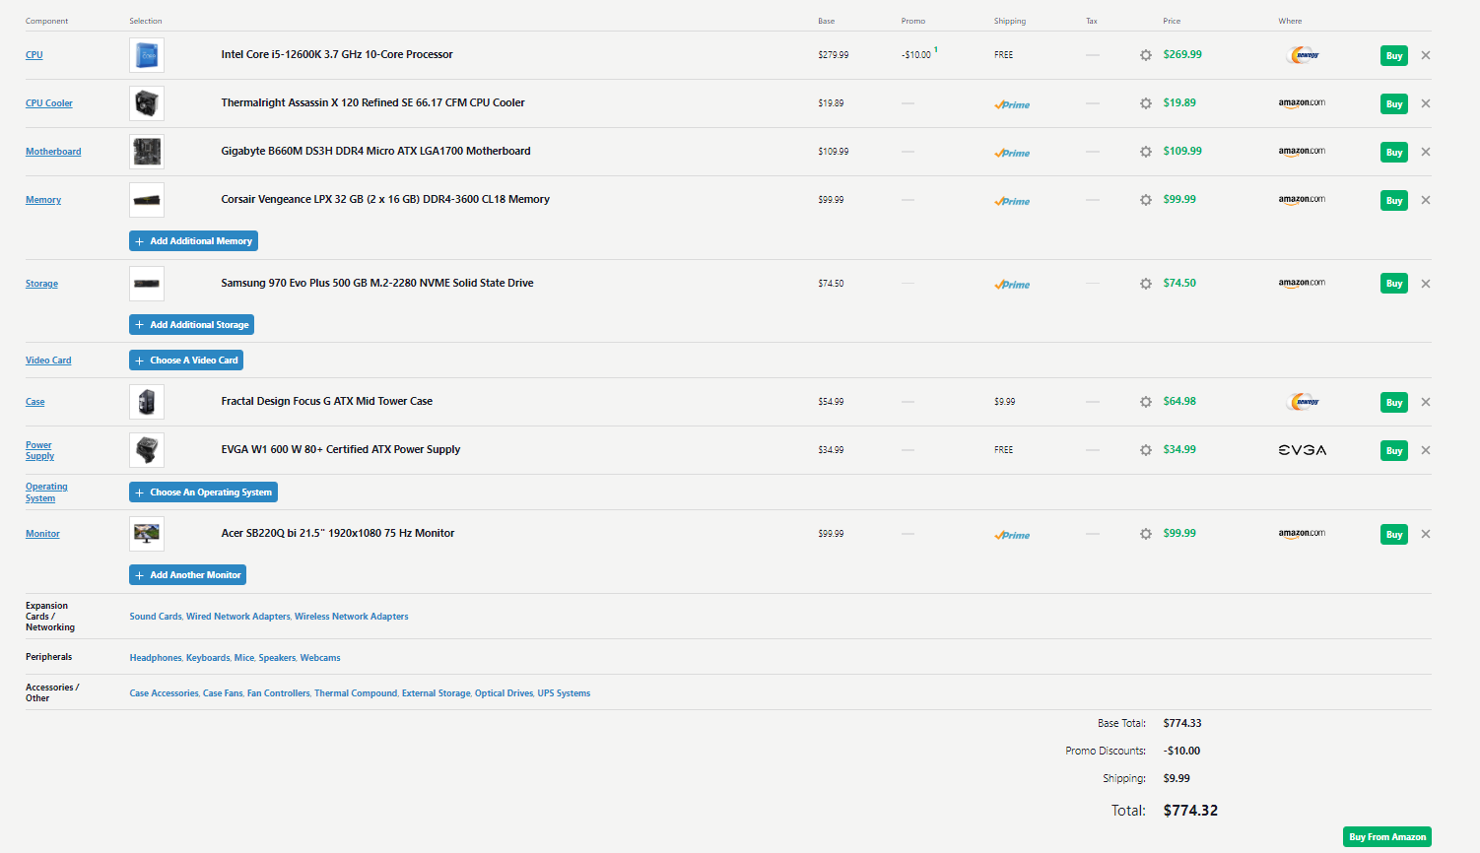**Total Cost: $ 774.32**